**Spring 2024: CS5720**

**Neural Networks & Deep Learning - ICP-1**

**700755549  
Venkata Naveen Grandhi**

Github : <https://github.com/naveen55490/neuralnetwork/tree/main/Assignment1>

1. – Input the string “Python” as a list of characters from console, delete at least 2 characters, reverse the resultantstring and print it.

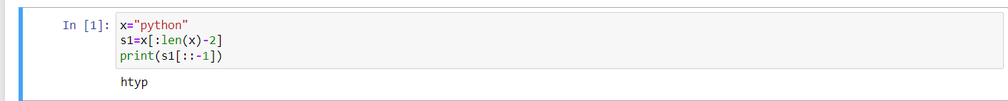Take two numbers from user and perform at least 4 arithmetic operations on them.  
  
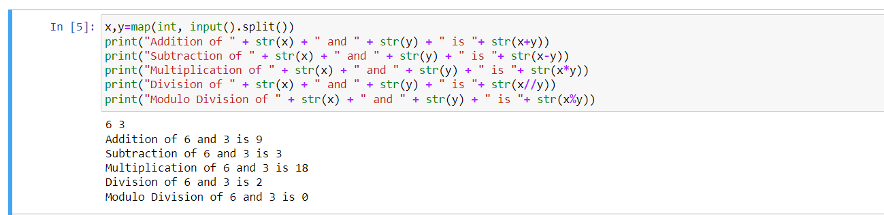  
  
  
  
**2.** Write a program that accepts a sentence and replace each occurrence of ‘python’ with ‘pythons’.  
  
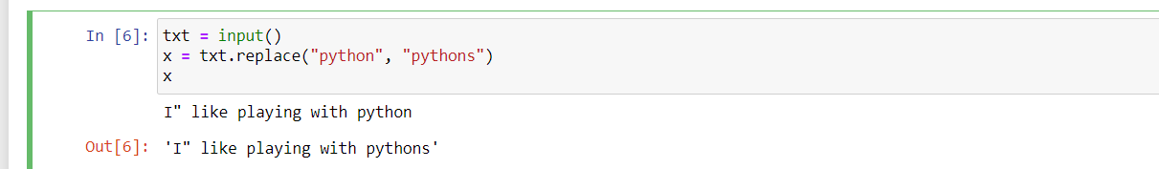  
  
  
 **3.** Use the if statement conditions to write a program to print the letter grade based on an input class score. Use the grading scheme we are using in this class.  
  
  
